Environments:

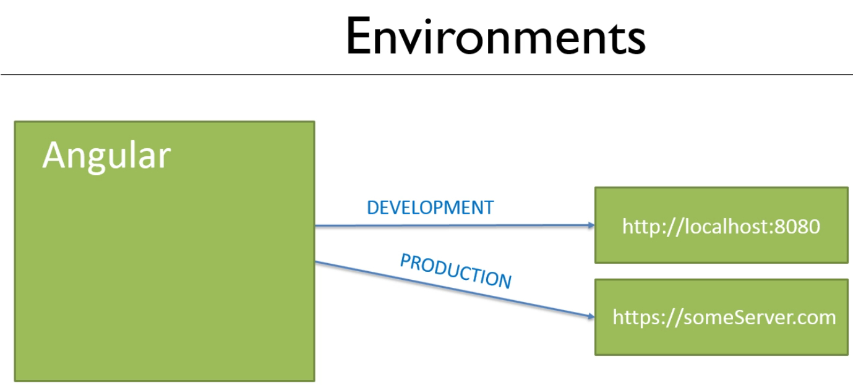

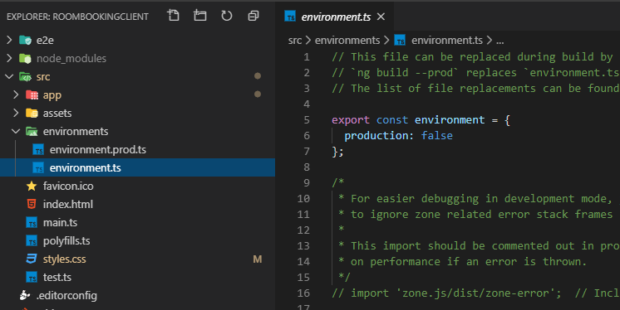

Production settings:

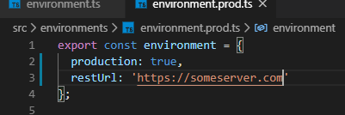

Dev settings:

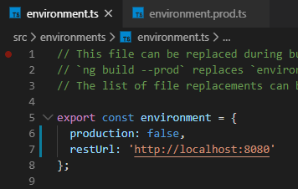

Setup a test in the constructor for the dataservice

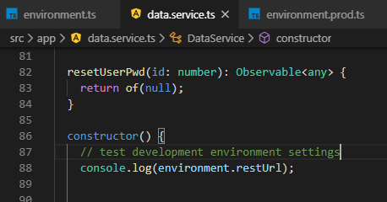

Test it in the console:

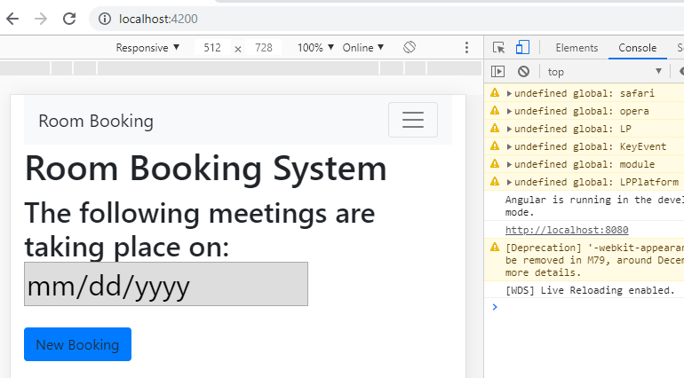

You can see the <http://localhost:8080>

To see the production settings type the following into the Terminal after stopping the application

With Ctrl + C and then Y to quit

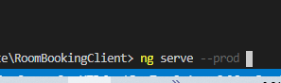

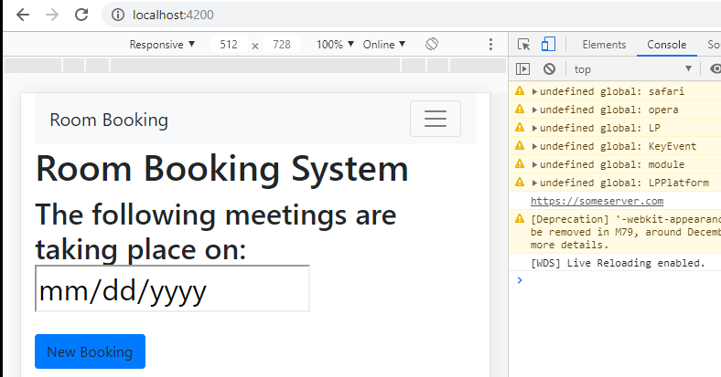

Here you can see the <https://someserver.com>

**How environments work?**

Look at angular.json file

The default is the environment.ts file!!

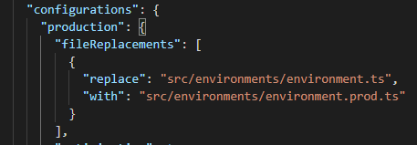

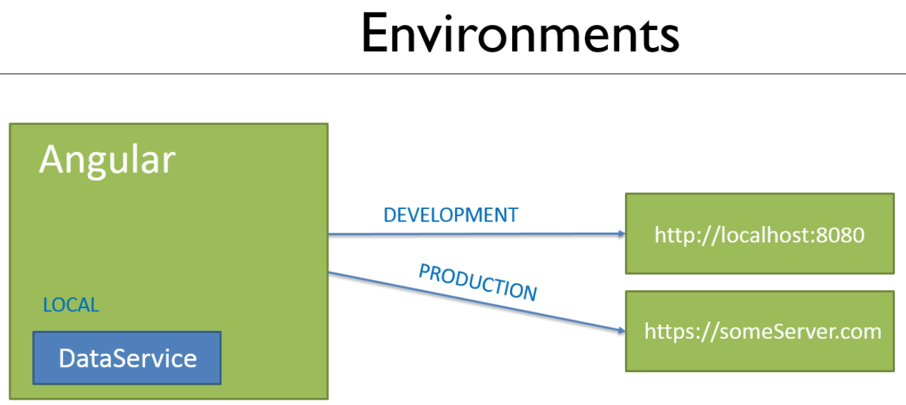

Local is a 3rd environment

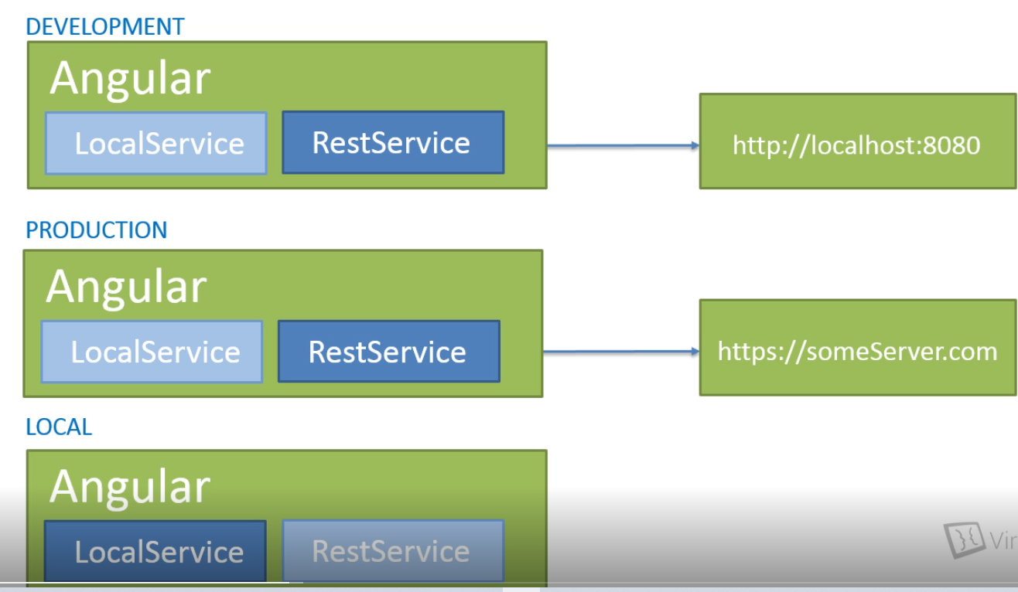

There is no url for the LocalService

Development should be the Default Configuration:

First, create the data.service.local.ts under the app folder

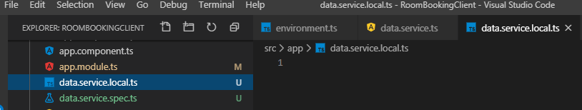

Paste in the data.service.ts contents

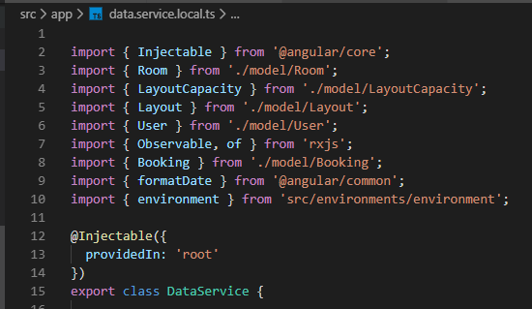

**In the data.service.ts - this is going to be the REST and production service!**

Remove the private variables

All public methods will return null

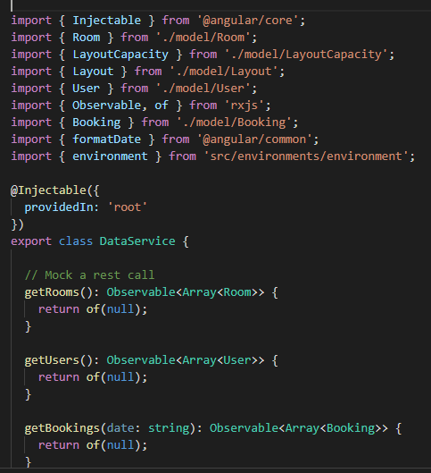

… and so on, until all public methods return of(null);

Remember to remove code between the return and what is in the body of the method

Now, in the constructor make it empty

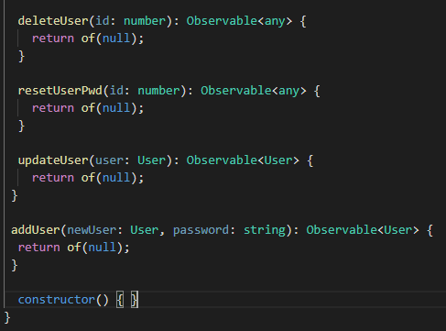

Check for successful compilation

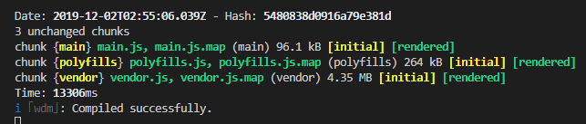

Modifications to the angular.json file

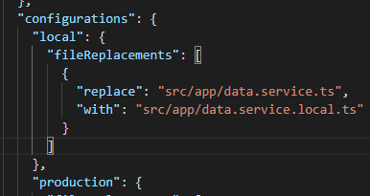

Add a local to serve section

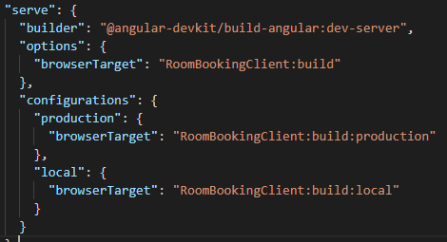

**Selecting an environment to serve**

**Create our own environments:**



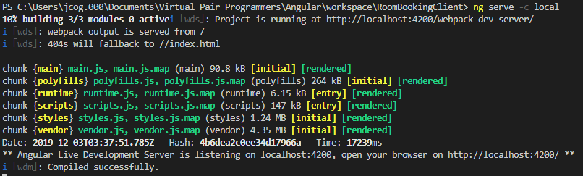

Check for data: You can see the user Joe, Theater and 12 --- DATA is present!!

Local is the standalone version!!

